- Given the scenario of a School Management System, identifyrelations and write SQL to list all students with their class teacher and grade.
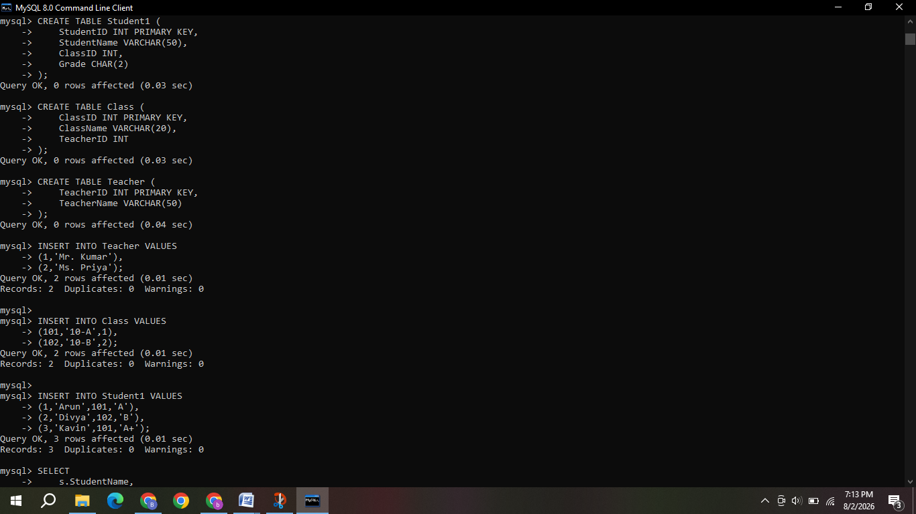
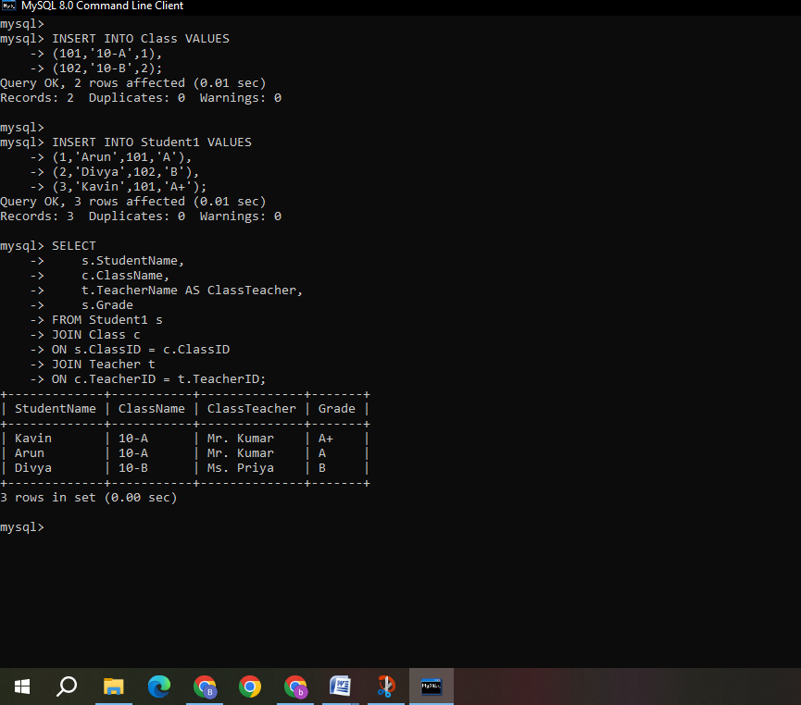

- A hospital wants to track patient appointments. Design the relational schema and write SQL to find doctors with more than 10 appointments this month.

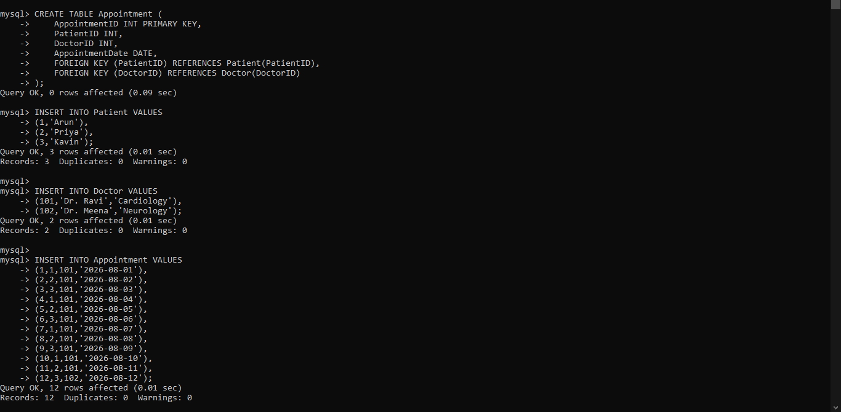
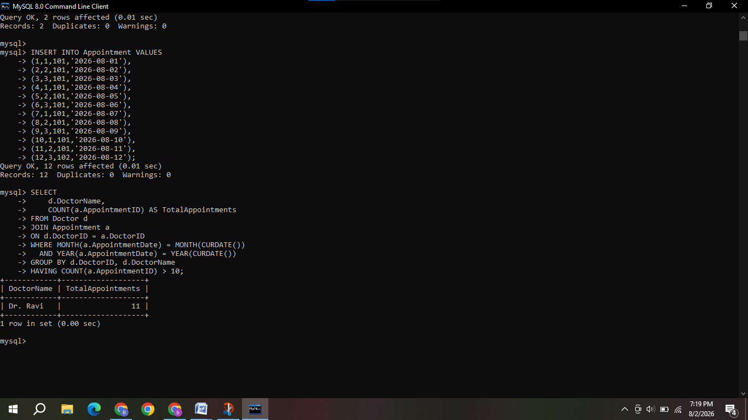

- In an e-commerce scenario, write SQL queries using sub-queries to find products that have never been ordered.

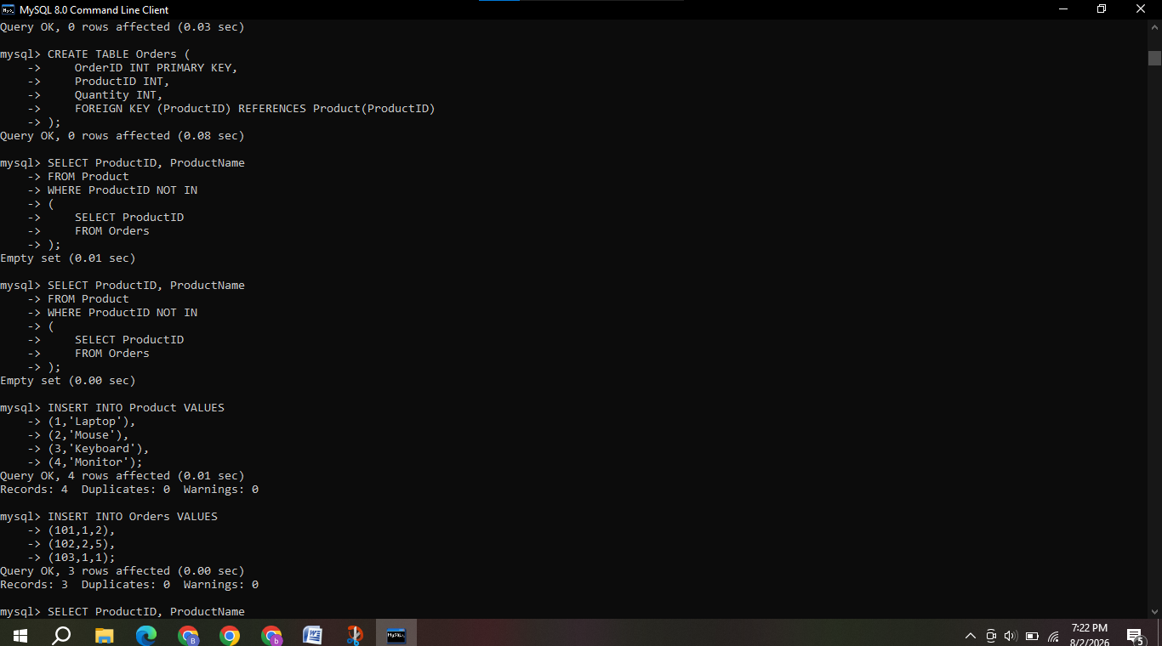
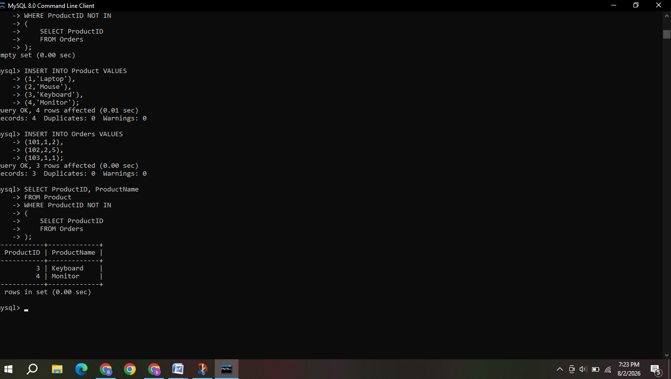

- For a university database, write relational algebra expressions to find students enrolled in both "DBMS" and "OS" courses.

Assume the following relations:
- Student(SID, Name)
- Course(CID, CName)
- Enrollment(SID, CID)

Relational Algebra Expression
1) Find students enrolled in DBMS:
$$DBMS_{Students}=π_{\left(SID\right)\left(Enrollment⋈σ_{\left(CName=^{'}DBMS^{'}\right)\left(Course\right)}\right)}$$
2) Students enrolled in OS
$$OS_{Students}=π_{\left(SID\right)\left(Enrollment⋈σ_{\left(CName=^{'}OS^{'}\right)\left(Course\right)}\right)}$$
3) Students enrolled in both courses
$$Result=DBMS_{Students}∩OS_{Students}$$
4) If student names are also required:
$$π_{\left(Name\right)\left(Student⋈\left(DBMS_{Students}∩OS_{Students}\right)\right)}$$

5) Given a payroll scenario, create a view showing employees whose salary is below department average and write a query to update their salary by 10%.
Assumed Table:
Employee(EmpID, EmpName, DeptID, Salary)
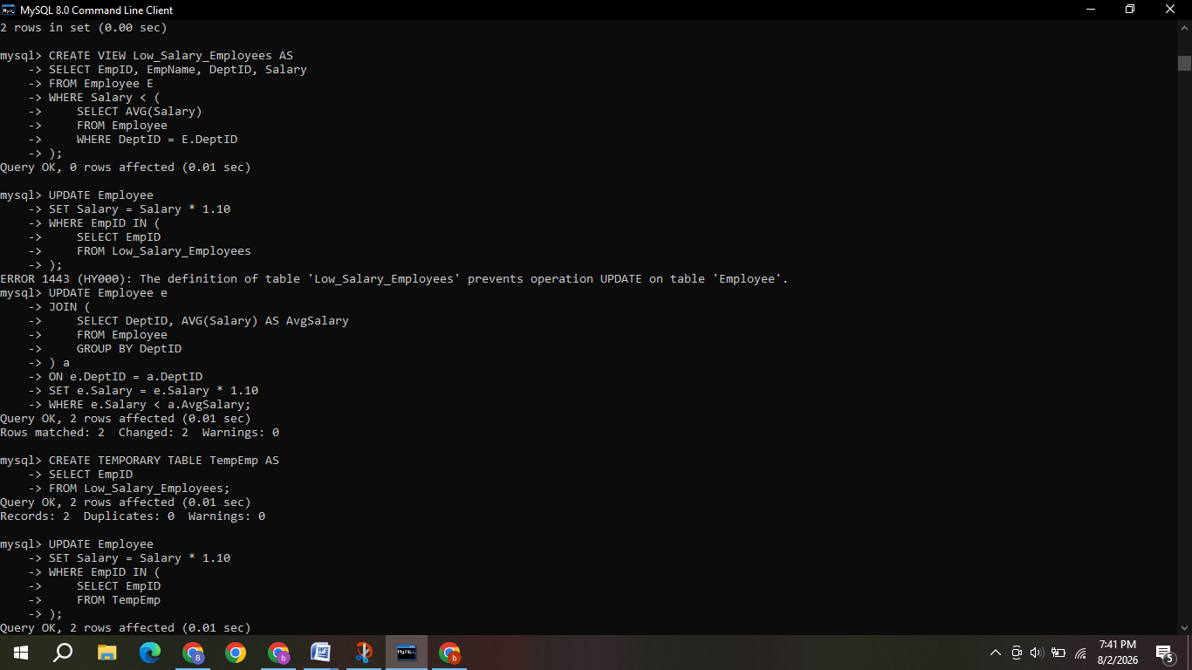
- In a banking scenario, apply JOIN operations to retrieve customer account details, transaction history, and branch information.
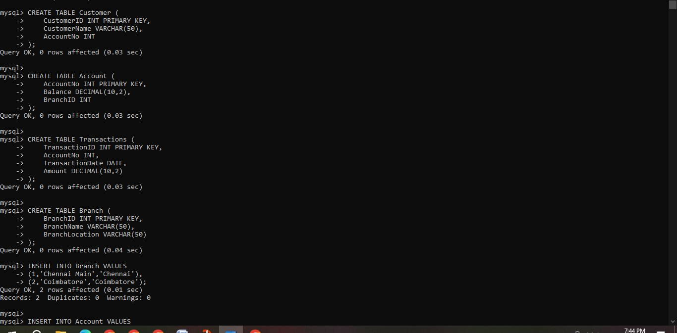
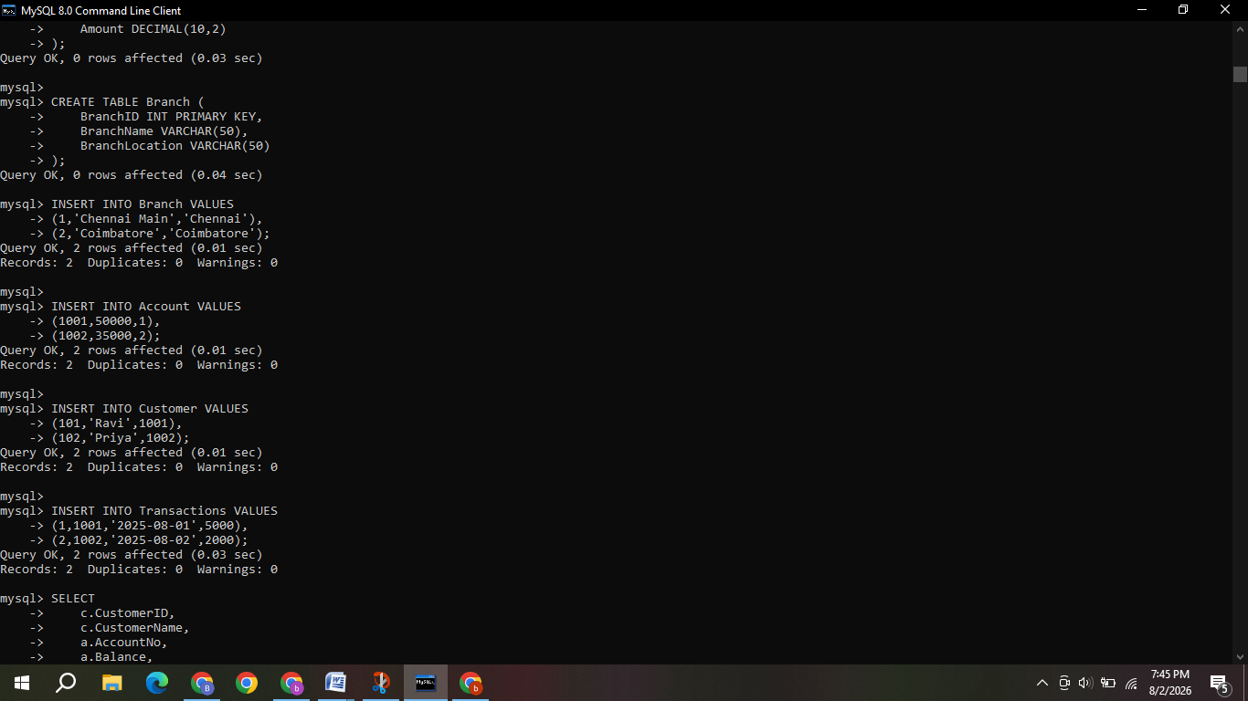
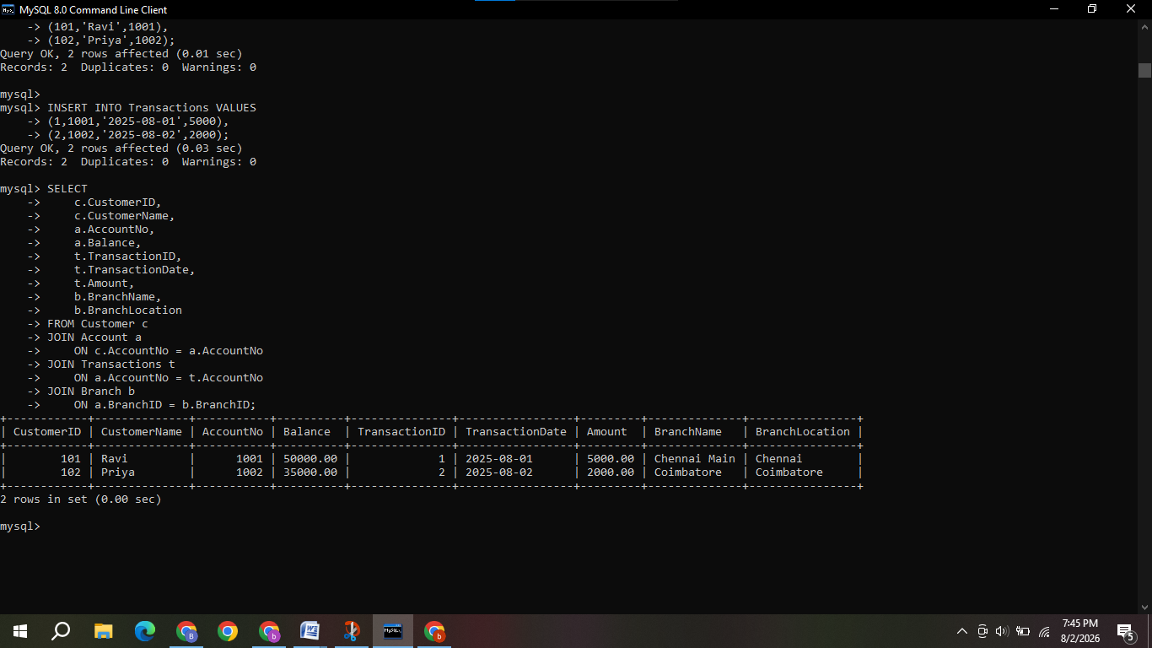

- A retail store needs daily sales summary. Write SQL with GROUP BY and HAVING to report total sales per category exceeding Rs.10,000.

Assumed Table

Sales(SaleID, ProductName, Category, Amount, SaleDate)

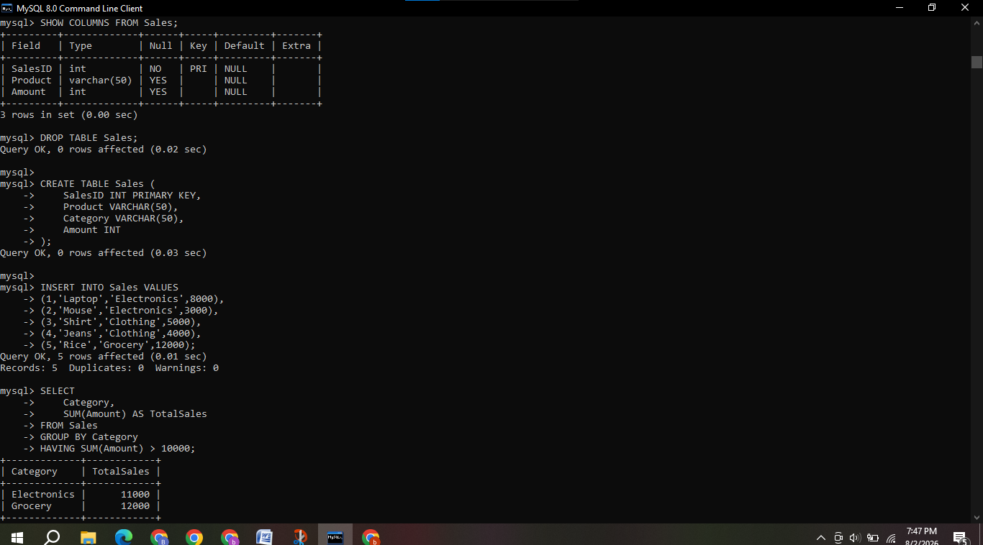

For a library system scenario, construct tuple relational calculus expressions to find members who borrowed books from all genres.

Assumed Relations
- Member(MemberID, MemberName)
- Book(BookID, Title, Genre)
- Borrow(MemberID, BookID)
Tuple Relational Calculus Expression:
{ m.MemberName |
Member(m) ∧
∀g (
∃b (Book(b) ∧ b.Genre = g.Genre)
→
∃br ∃bk (
Borrow(br) ∧
Book(bk) ∧
br.MemberID = m.MemberID ∧
br.BookID = bk.BookID ∧
bk.Genre = g.Genre
)
)
}
- Given an inventory management scenario, define CHECK and FOREIGN KEY constraints and demonstrate their enforcement through SQL.
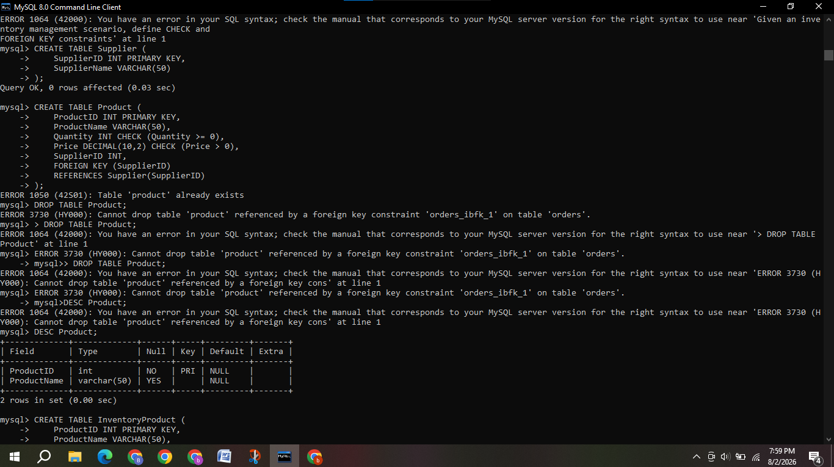
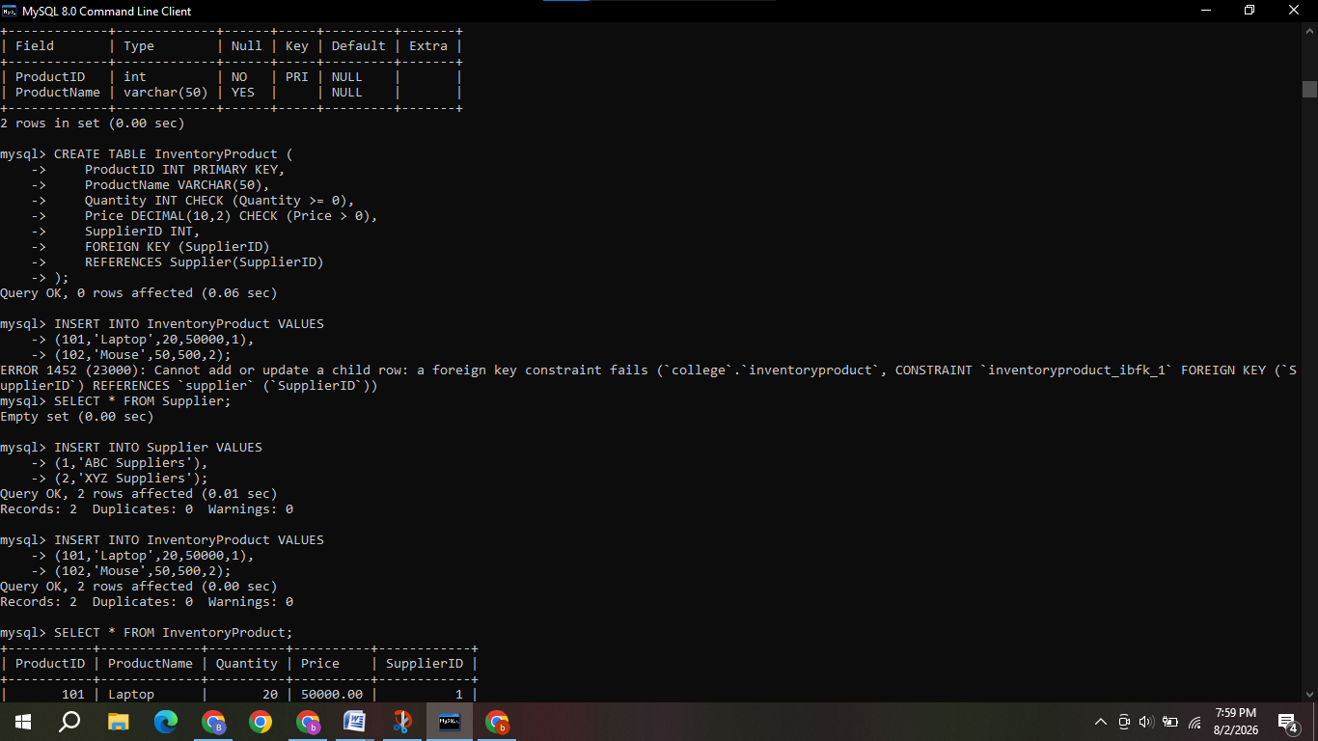
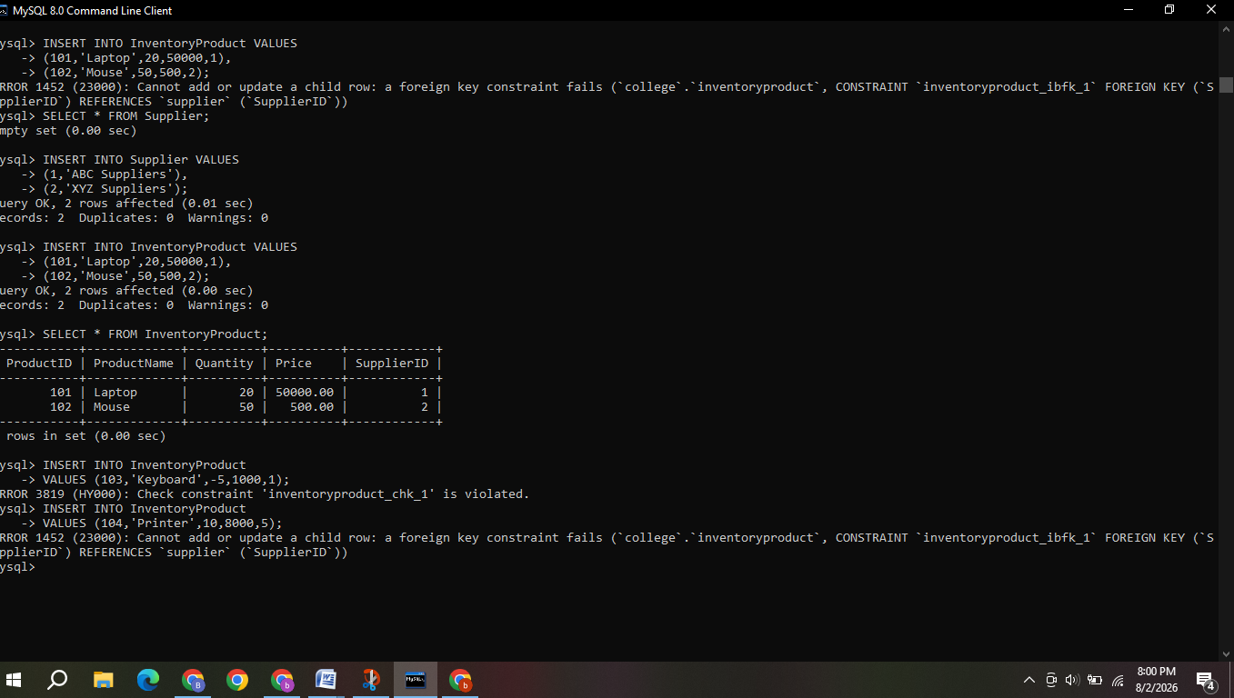

- Design a relational schema for an HR system and create materialized views for monthly attendance and performance summaries.
